Relationship between solar radio flux F10.7 and sunspot number.  
Eugenii Israelit, Dmitry Shadrin, Skoltech, 2016

*Main goal of the lab:*

To understand the relationship between main indicators of solar activity, sunspot number and the solar radio flux at 10.7 cm (2800 MHz) by applying multi-dimensional linear regression technique.

*Description:*

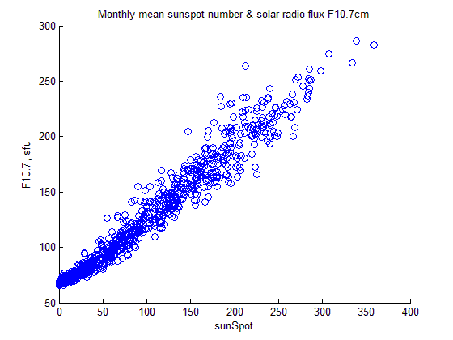Sunspot number and solar radio flux at 10.7 cm are main indicators of solar activity. Sunspot number is daily measured by observatories over the globe and is determined as $R=k(n+10g)$  
, here $n$– number of observed sunspots, $g$– number of observed sunspot groups, $k$– coefficient of a telescope. Solar radio flux at 10.7 cm is a measurement of radio emission at a wavelength of 10.7 cm (2800 MHz) from all sources present on the solar disk (sunspots, solar flares, solar proton events, white light faculae fields).

Scatter plot between monthly mean sunspot number and solar radio flux F10.7cm by using data set №1

It can be seen that there is a correlation between monthly mean sunspot number and solar radio flux.

Then the data was smoothed according to the formula (13-month running mean $\overline{R}$):

$$\overline{R}=\frac{1}{24}R_{i-6}+\frac{1}{12}{(R}_{i-5}+R_{i-4}+…+R_{i-1}+R_{i}+R_{i+1}+…+R_{i+5})+\frac{1}{24}R_{i+6}$$

(First and last six months are simply averaged)

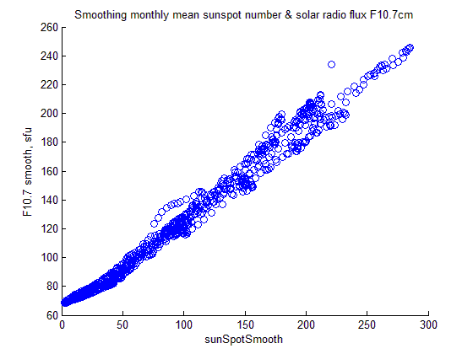It can be seen that here is a STRONGER correlation between monthly mean sunspot number and solar radio flux F10.7cm

In the graph below we can see that there is a strong correlation according to the time between sunspot number and solar radio flux. Correspondence of peaks are very close.

Multi-dimensional linear regression linear regression was constructed by using following formulas and smoothed data:

$F_{i}=β_{0}+β_{1}R_{i}+β_{2}R_{i}^{2}+β_{3}R_{i}^{3}{+ε}_{i}$ (1)

$F=\left|\begin{aligned}\begin{matrix}f_{1} \\ f_{2} \\ …\end{matrix} \\ f_{N}\end{aligned}\right|$– Vector of dependent variables, regressand, solar radio flux at 10.7 cm

$R=\left|\begin{matrix}1 & r_{1} & r_{1}^{2} & r_{1}^{3} \\ 1 & r_{2} & r_{2}^{2} & r_{2}^{3} \\ … & … & … & … \\ 1 & r_{N} & r_{N}^{2} & r_{N}^{3}\end{matrix}\right|$– Matrix of independent variables, regressors

- vector of coefficients

Vector of coefficients was determined by LSM: $β={\left(R^{T}R\right)}^{-1}R^{T}F$

The result is: $β_{0}=$ 65,79694 $β_{1}=$ 0,46189 $β_{2}=$ 0,00169 $β_{3}=$-4,00159e-06

By substituting these coefficients and smoothed mean sunspot number to Eq (1) solar radio flux at 10.7 cm were reconstructed.

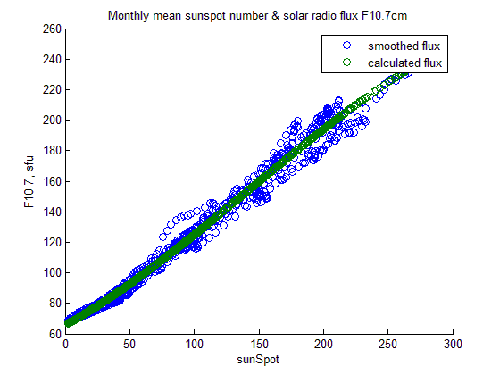The difference between reconstructed solar radio flux and smoothed solar radio flux is sown below.

It can be noticed very close correspondence of two curves.

The variance of estimation error of solar radio flux flux at 10.7 was determined according to the formula:

$$σ^{2}=\frac{1}{N-1}\sum_{i=1}^{N}{{\left(f_{i}-\hat{f_{i}}\right)}^{2}}=38.3318$$

*Conclusion:* The strong relationship between sunspot number and solar radio flux was shown by applying multi-dimensional technique. The code was developed in Matlab. Also a lot of experience in using Matlab in data processing (smoothing..) were received.

## Appendix 1: MatLab Source code

clc; clear; close all;  
  
Data = importdata('data_group1.mat');  
SunSpot = Data(:,5);  
Flux = Data(:,4);  
  
% 13-month running mean  
SunSpotSmooth = smooth(SunSpot);  
FluxSmooth = smooth(Flux);  
  
% Reconstruct solar radio flux on the basis of sunspot number  
FluxCalc = calculateFlux(SunSpotSmooth,FluxSmooth);  
  
% The variance of estimation error of solar ratio flux at 10.7  
var(FluxSmooth-FluxCalc)

function SmoothArray = smooth(Array)  
  
%13-month running mean  
n = length(Array);  
SmoothArray(n) = zeros();  
SmoothArray(1:6) = mean(Array(1:6));  
for i = 7 : n-6  
 SmoothArray(i) = sum(Array(i-5:i+5))/12 + (Array(i-6)+Array(i+6))/24;  
end  
SmoothArray(n-5:n)=mean(Array(end-5:end));

function FluxCalc = calculateFlux(SunSpotSmooth,FluxSmooth)  
  
len = length(SunSpotSmooth);  
  
F = FluxSmooth';  
S = SunSpotSmooth';  
R = [ones(len, 1) S S.^2 S.^3];  
  
% Determine vector of coefficients  
B=((R'*R)\R')*F;  
  
FluxCalc = B(1) + B(2)*SunSpotSmooth + B(3)*SunSpotSmooth.^2 +B(4)*SunSpotSmooth.^3;

## Graphs

% Convert Time to Years (for displaying in Plots)  
Time = (Data(:,3)-717428)./365 + 1964;  
  
figure, plot(Time, SunSpot, Time, SunSpotSmooth);  
title('SunSpot and SunSpotSmooth');  
xlabel('time'), ylabel('SunSpot');  
legend('SunSpot', 'SunSpotSmooth');  
  
figure, plot(Time, Flux, Time, FluxSmooth);  
title('Flux and FluxSmooth');  
xlabel('time'), ylabel('Flux');  
legend('Flux', 'FluxSmooth');  
  
figure, plot (Time, SunSpot, Time, Flux);  
title ('Dependence of smoothing monthly mean sunspot number & solar radio flux F10.7cm on Time');  
legend('sunSpot','flux, sfu');  
xlabel('Time, years');  
  
figure, plot (Time, SunSpotSmooth, Time, FluxSmooth);  
title ('Dependence of smoothing monthly mean sunspot number & solar radio flux F10.7cm on Time');  
legend('sunSpotSmooth','fluxSmooth, sfu');  
xlabel('Time, years');  
  
figure, scatter(SunSpot, Flux), xlabel('sun'), ylabel('flux');  
title('Correlation between SunSpots and Flux');  
xlabel('SunSpot'), ylabel('Flux');  
  
figure, scatter(SunSpotSmooth, FluxSmooth), xlabel('sunSmooth'), ylabel('fluxSmooth');  
title('Correlation between SunSpotsSmooth and FluxSmooth');  
xlabel('SunSpotSmooth'), ylabel('FluxSmooth');  
  
figure, plot(Time, FluxCalc, Time, FluxSmooth);  
title('FluxCalc VS FluxSmooth');  
xlabel('time'), ylabel('flux');  
legend('FluxCalc', 'FluxSmooth');  
  
figure, scatter(SunSpotSmooth, FluxSmooth);  
hold, scatter ( SunSpotSmooth, FluxCalc);  
title ('Monthly mean sunspot number & solar radio flux F10.7cm');  
legend ('smoothed flux', 'calculated flux');  
xlabel('sunSpot'), ylabel('F10.7, sfu');

## Appendix 2: additional Graphs

